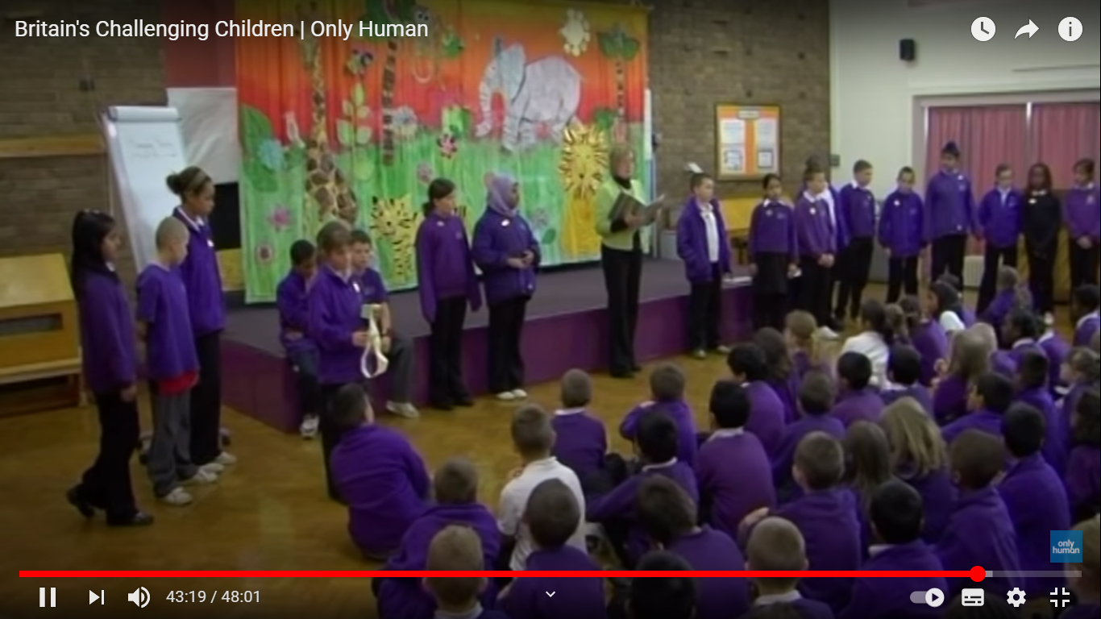

**Morning Assembly where prizes are awarded / given away**

Those who have made progress and done well in e.g. numeracy will get a prize and will be commended / praised after having been recommended / nominated. It could also be due to other things such as having been the best friend or eco warrior of the month

This sort of arrangement / event is so typically British and at the same time so atypically Danish – perhaps we should follow suit. The pupil in question feels that he/she is something. Back in the day there was a political campaign and also a national evaluatin called ‘Every child counts’